APPENDIX

PATENT DISCLOSURE FORM

 | SRM INSTITUTE OF SCIENCE AND TECHNOLOGY KATTANKULATHUR – 603203
Application for patent filing
 |  |  | Date | D | D | M | M | Y | Y | Y | Y
 |  |  |  | 3 | 0 | 0 | 4 | 2 | 0 | 2 | 5
Name of the Faculty | : | Dr. R.Babu
Department | : | Department of Computational Intelligence
Faculty ID Number | : | 102893
Official E-mail ID | : | babur@srmist.edu.in
Personal E-mail ID | : | babu.rajen17@gmail.com
Contact number: |  | 7010691102
Major area of invention | : | A portable, real-time, communication system that translates hand gestures into complete natural language sentences using AI-based gesture recognition and text-  to-speech output for disabled individuals.
Narrow focus area of invention | : | Real-time translation of predefined hand gestures into natural sentences and voice output for speech- and  hearing-impaired individuals
Title of the invention |  | Hand Gesture-Based Communication System for  Disabled Individual
Earlier status of research | : | Earlier systems relied on expensive hardware, static gesture recognition, and required internet connectivity without offering real-time, natural sentence  communication.
How different your invention from similar research / others - Novelty? | : | GestureTalk integrates gesture recognition, real-time translation, speech output, and accessibility support within one seamless solution designed for simplicity.  Unlike other systems that require multiple tools or

devices to interpret sign language, our project offers a unified communication platform powered by a modular architecture, enabling instant and accurate gesture-to- speech conversion across all supported sign types
simultaneously.
Possible domain for field application | : | - Assistive Communication Technology  - Accessibility Enhancement in Mobile & IoT Devices  - Smart Healthcare Solutions  - Human-Computer Interaction (HCI)  - Education & Awareness for the Disabled Community
Possible sector for commercialization | : | - Individual consumers  - Small and medium businesses  - Educational institutions  - Healthcare organizations
Faculty Signature with date | :
HoD Remarks / Recommendation for filing patent | :
Application received by The Review committee on | :
Review committee remarks | :

PATENT APPLICATION
Invention Disclosure Form To be filled by the inventors

Please provide highly relevant information for details asked below and use consistent language while describing the specific feature or element in the invention disclosure.
1. | Title of invention  Hand Gesture-Based Communication System for Disabled Individual
2. | Describe the invention  GestureTalk is an innovative communication system designed to translate hand gestures into speech for individuals with hearing or speech impairments. The system uses a tag-type device with an ultra-wide camera, coupled with gesture recognition algorithms, to accurately detect sign language. It then converts these gestures into real-time speech output. Built with modular hardware and software architecture, GestureTalk is compact, portable, and accessible, providing a unified assistive solution for the disabled community.
3. | Does the invention provide a new use of or improvement to an existing product or process?  Yes, GestureTalk offers significant improvements over traditional communication aids. Existing solutions often require specialized gloves or predefined gesture sets and lack real-time conversion. In contrast, GestureTalk enables seamless gesture recognition without wearable devices, offers real-time feedback, and integrates speech output, improving the speed, convenience, and accuracy of gesture-based communication.
4. | State the Novelty of the invention and specify the claims in the invention  - A non-intrusive gesture recognition system that does not require wearables or physical attachments.  - Real-time gesture-to-speech translation using camera-based input.  - Modular hardware design compatible with Raspberry Pi or Arduino platforms.  - Adaptive gesture recognition model that improves accuracy over time based on usage patterns.
5. | Describe the advantages of the present invention over the existing technologies  - User-Friendly: Eliminates the need for users to wear gloves or sensors.  - Accessibility: Affordable and designed for easy use by individuals of all ages and technical skill levels.  - Real-Time Output: Offers instant gesture recognition and speech conversion.  - Customizability: Supports training of new gestures for regional or user- specific sign languages.
6. | Describe how the present invention overcomes the drawbacks of currently available technology related to your invention.  - Eliminates Wearables: Many systems rely on specialized gloves or sensors; GestureTalk only requires a camera.  - Improved Real-Time Communication: Unlike devices with lag or delay, our system focuses on instantaneous conversion.

- Scalability and Portability: Runs on affordable, widely available platforms like Raspberry Pi.
- Inclusive Design: Designed to be intuitive and accessible for disabled individuals and caregivers.
7. | Describe uses, applications and benefits of the invention.  - Personal Communication Aid: Helps individuals with speech or hearing disabilities communicate effectively in real-time.  - Educational Tool: Useful in special education environments for both teaching and assisting students.  - Healthcare Communication: Enables better communication in hospitals or rehabilitation centers.  - Public Service Utility: Can be used at service counters, transportation hubs, or banks to assist communication.
8. | Does the focus of the invention results in societal impact technology?  GestureTalk addresses social inclusion by empowering disabled individuals with a reliable communication tool. It bridges the communication gap, fosters independence, and enhances confidence. The system contributes to inclusive education, accessible healthcare, and improved quality of life, especially in underserved areas where sign language interpreters are unavailable. It also promotes awareness and empathy towards the disabled community.
9. | Characterize the disadvantages and limitations of the invention  - Environmental Limitations: Performance may be affected in poor lighting or cluttered backgrounds.  - Gesture Variability: May initially struggle with inconsistent or regional gestures until trained.  - Hardware Constraints: Limited by camera resolution and processing power of embedded systems.  - Privacy Considerations: Continuous camera monitoring raises privacy concerns, requiring transparent policies.  - Language Dependency: Focused on gesture-to-speech in a single spoken language; multilingual support is still under development.

10. | Enclose the sketches, drawings, photographs and other materials that help in better understating/ illustration of the novelty in the invention.  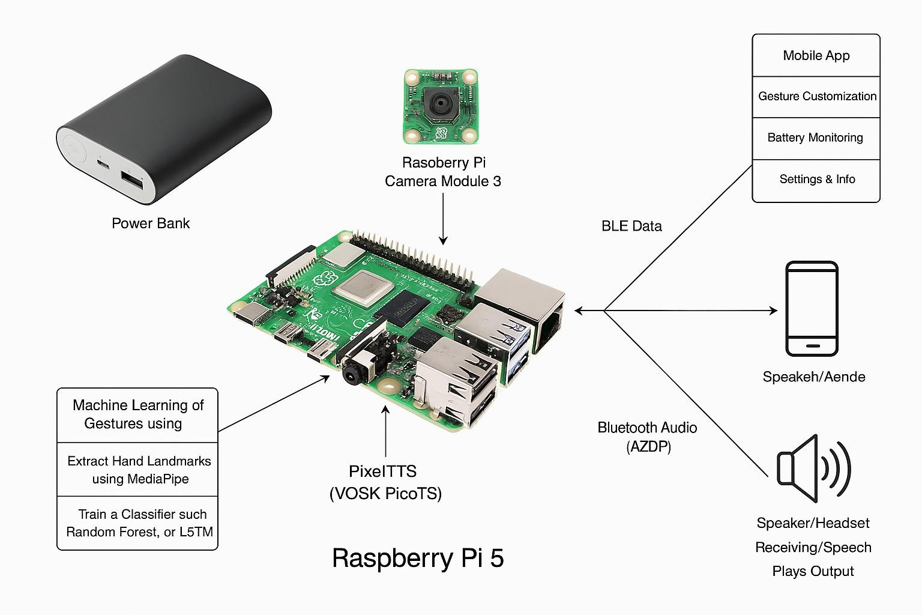
11  . | Current development status of the invention  - Has Your Invention Been Tested Experimentally? Yes, GestureTalk has been tested in a controlled environment using various static and dynamic gestures.  - Describe the Experimental Approach of the Invention Also State the Methods Adopted in the Experiment. GestureTalk was tested using a Raspberry Pi-based prototype equipped with an ultra-wide camera. Tests included detecting standard Indian Sign Language gestures with varying lighting and distances. Users interacted with the system for real-time gesture-to-speech output, and performance was logged for accuracy, latency, and usability.  - Are the Experimental Data Documented in a Formal Log or Any Instrumental Confirmation Available for the Invention? Yes, test logs, performance metrics, user accuracy reports, and hardware setup documentation are maintained and available in a shared research repository.  - Is Further Development of Your Invention Necessary or Development of the Invention is in Progress? Yes, development is ongoing. Planned enhancements include:  - Deep learning model integration for adaptive recognition  - Multilingual speech support  - Mobile app extension  - Power optimization for longer battery life  - Voice tone customization for different user preferences

13. INVENTOR(S) AND/OR CONTRIBUTOR(S):
 | INVENTOR (1) |  | INVENTOR (2)
Name: | Jeevan Baabu Murugan |  | Surya Sathyanarayanan
Address: | Department of, CINTEL SRM IST, Kattankulathur campus-603203 |  | Department of CINTEL, SRM IST, Kattankulathur campus-603203
City and State: | Chennai &Tamilnadu |  | Chennai &Tamilnadu
Citizenship (Country): | INDIAN |  | INDIAN
Email Id:  (official and  personal ID is required) | jm7531@srmist.edu.in jeevanbaabu03@gmail.com |  | ss7626@srmist.edu.in surya.sdp2004@gmail.com
Contact number: | 8438844636 |  | 8838335431

